A CRM Application to Manage the Services offered by an Institution

**Phase 2: Org Setup & Configuration**

**Step 1: Goal of Phase 2**

* Prepare Salesforce environment.
* Setup Users, Roles, Profiles, Permissions.
* Configure Company Info, Business Hours, Holidays, Fiscal Year.
* Expected Outcome (Phase 2 Goal): Org ready for Phase 3 (Data Modeling & Relationships).

**Step 2: Salesforce Editions**

* Use Developer Edition Org (free).
* Already account exists → login.
* Dev Org = sandbox for build/test.

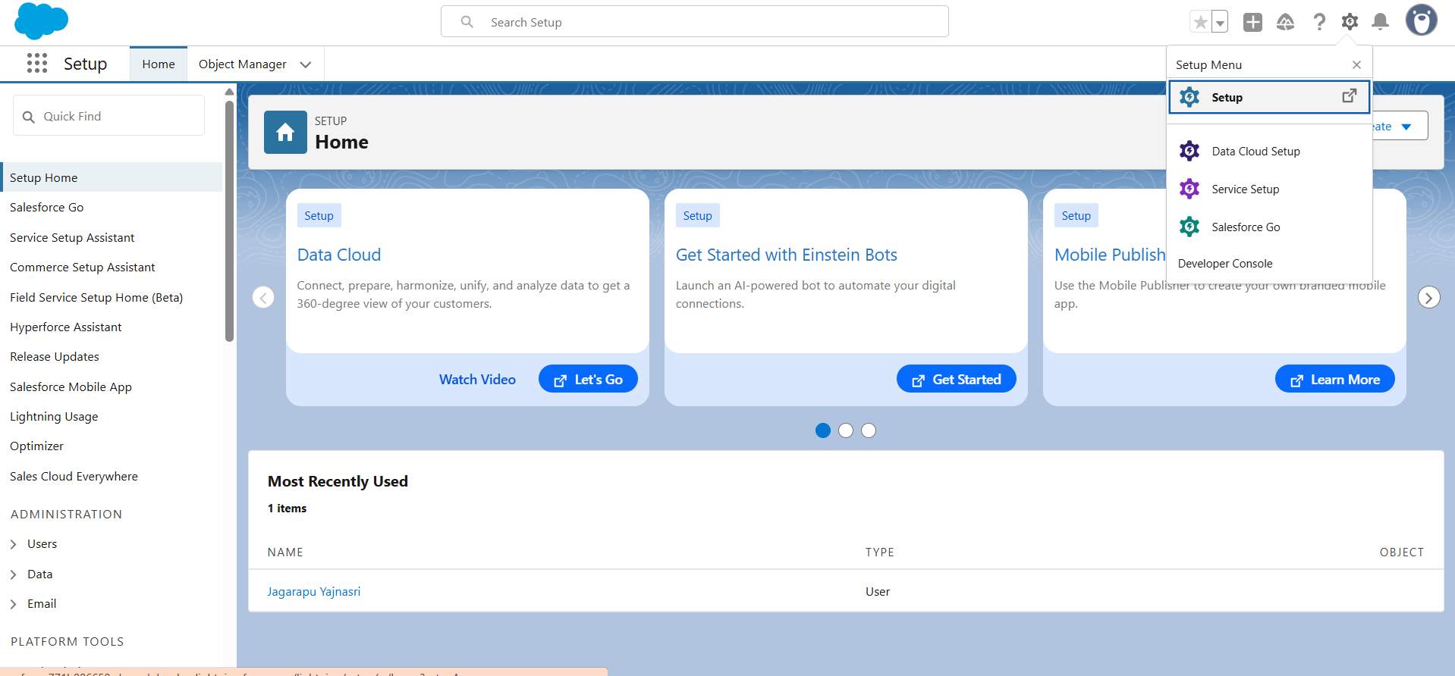

**Step 3: Company Profile Setup**

* Setup → Company Settings → Company Information.
* Fill details: Name, Timezone, Currency.
* Save.

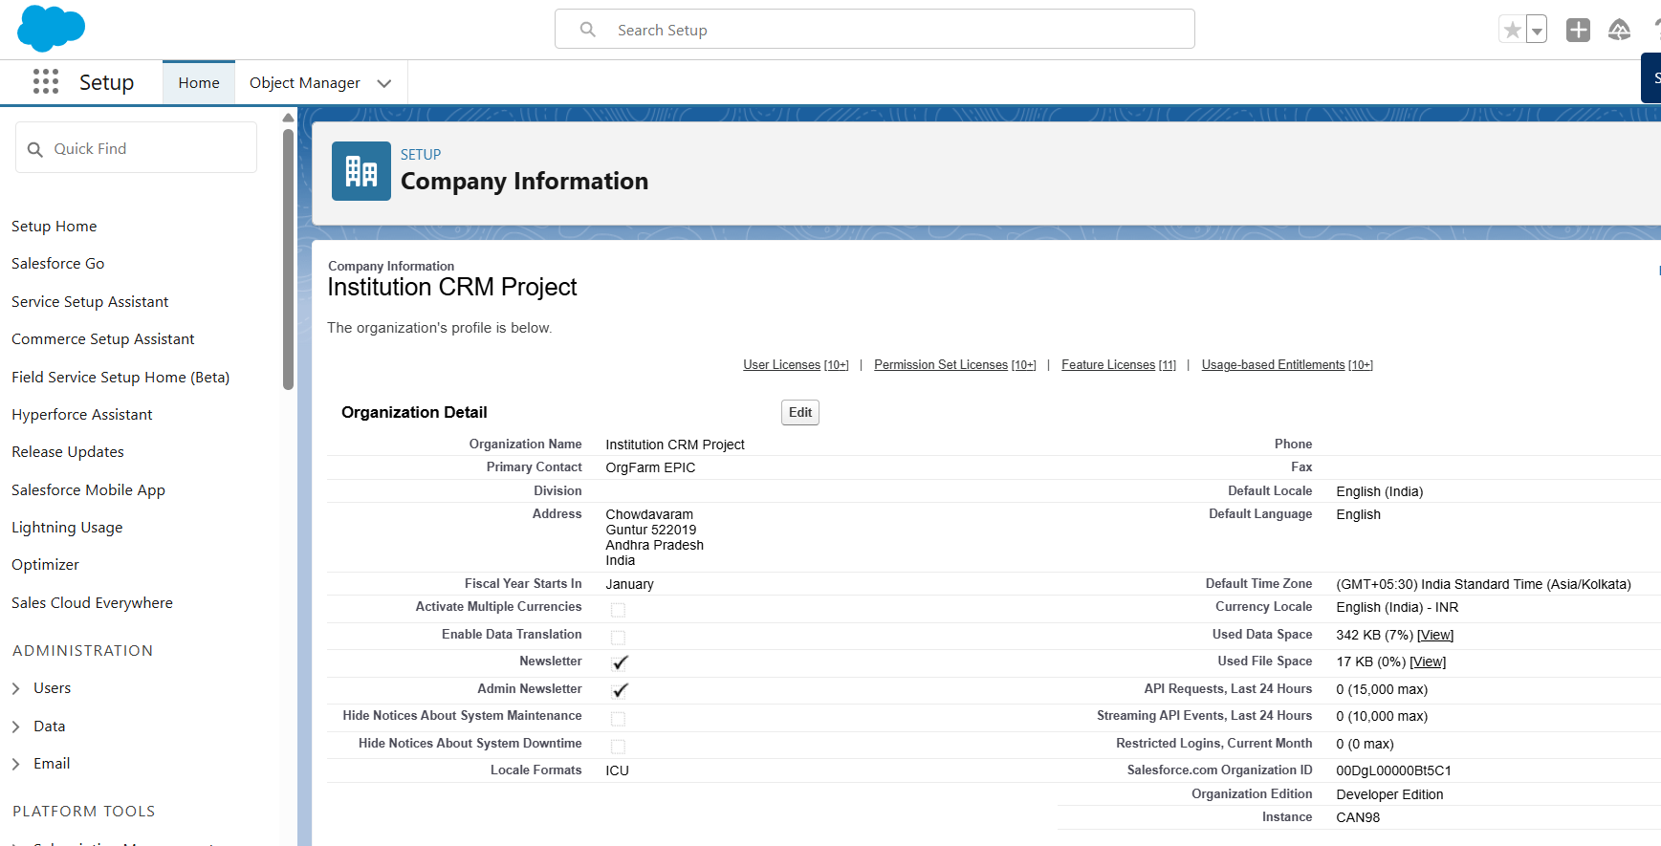

**Step 4: Business Hours & Holidays**

* Setup → Business Hours → New → 9 AM – 6 PM.
* Holidays → Add public holidays.

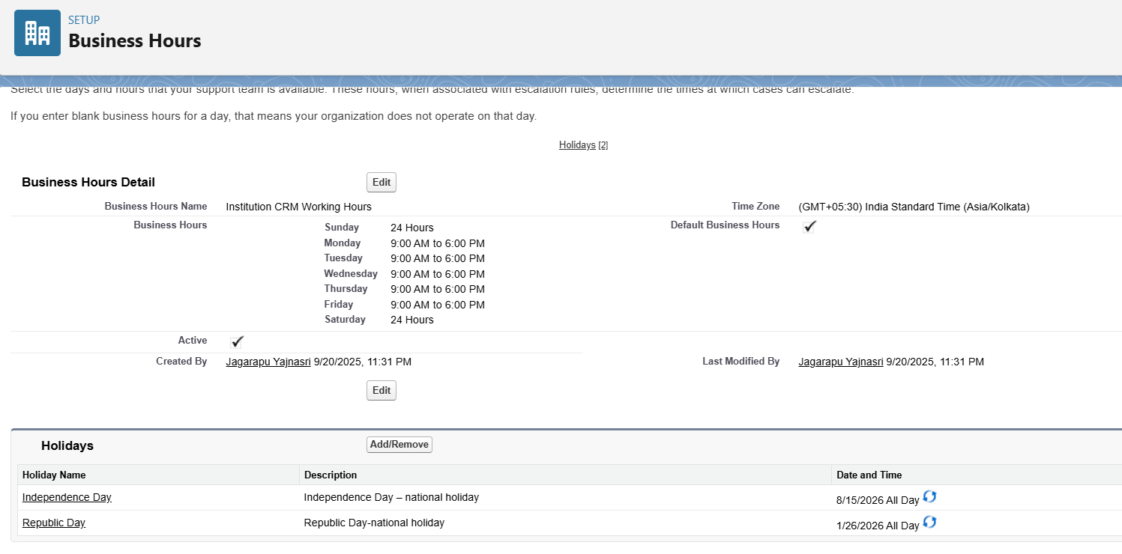

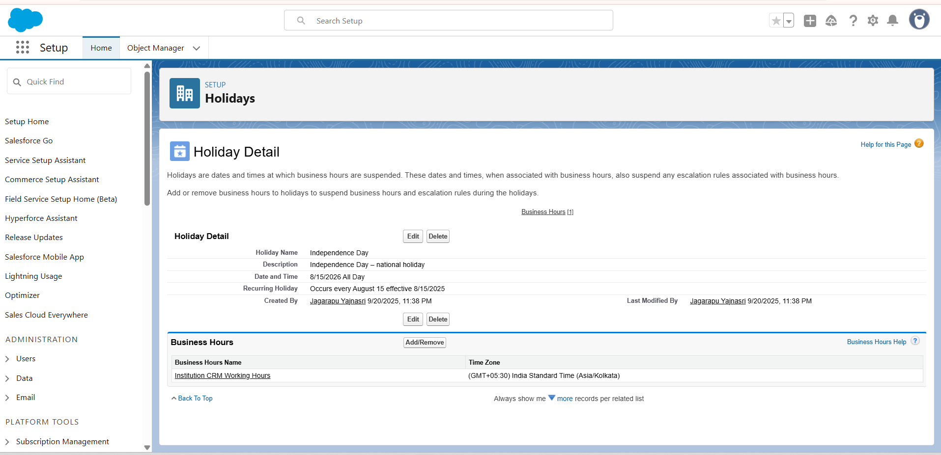

**Step 5: Fiscal Year settings**

* Setup-> Fiscal Year -> standard (jan-Dec)
* Save

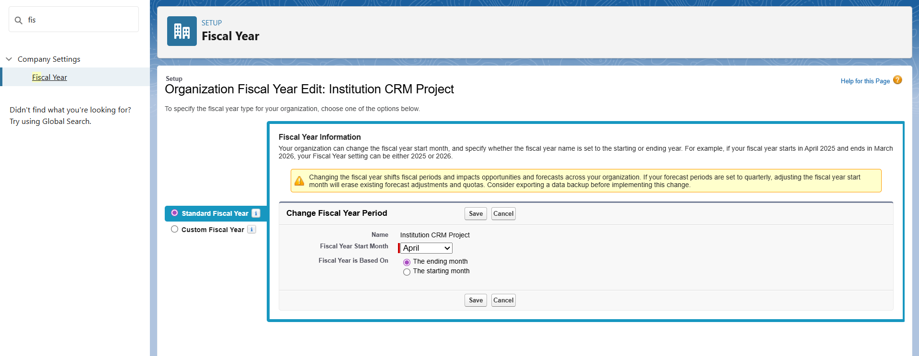

**Step 6: Users & Licenses**

* Setup → Users → New User
* Create: Admin, Manager, Collection Staff
* Assign Salesforce license

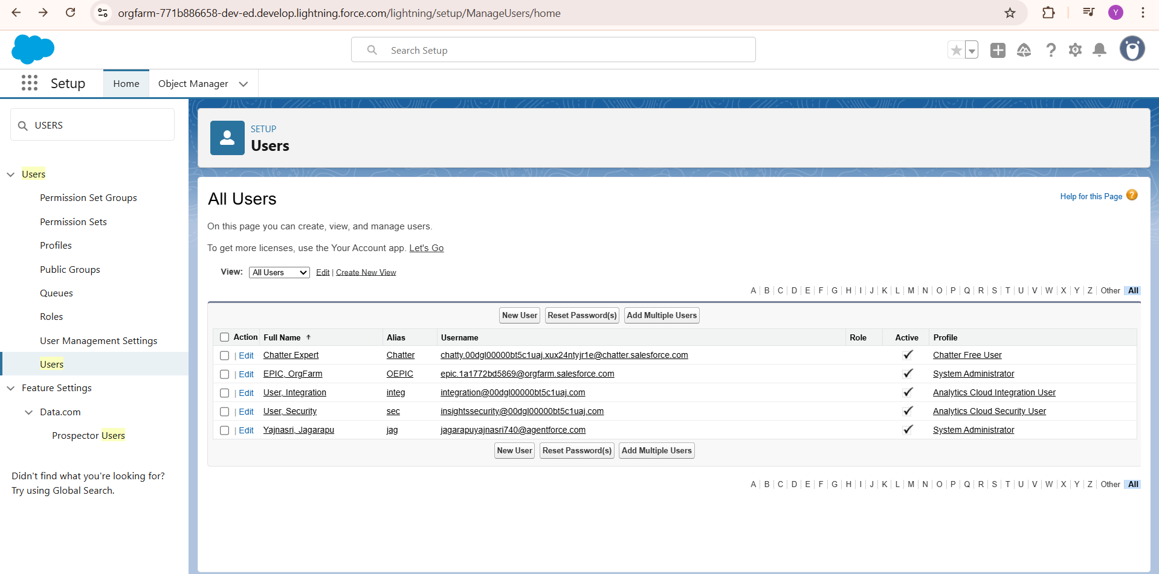

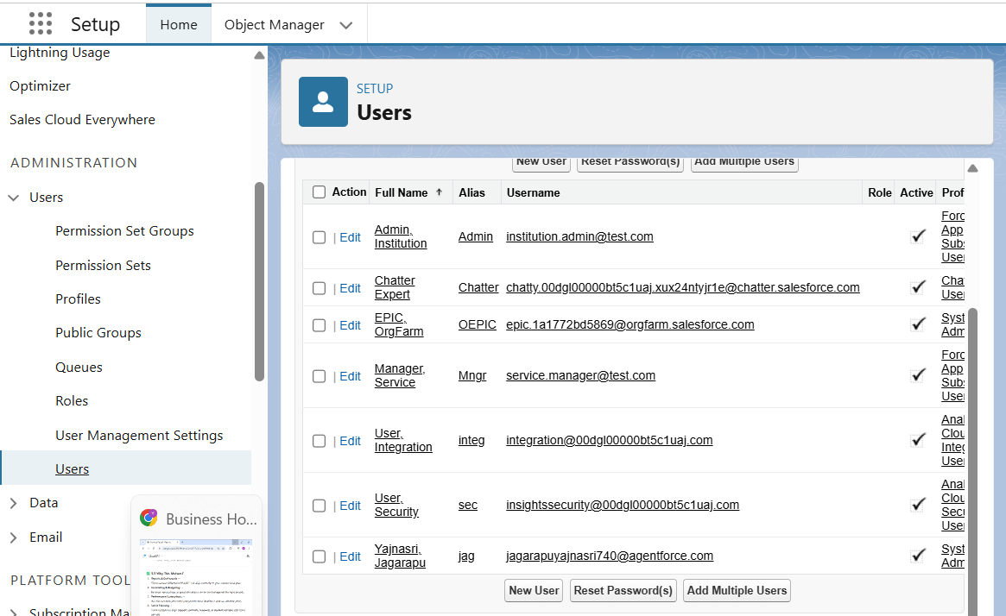

**Step 7: Profiles**

* **Collection Staff** → create/update tasks
* **Manager** → full access
* **Admin** → full + setup permissions

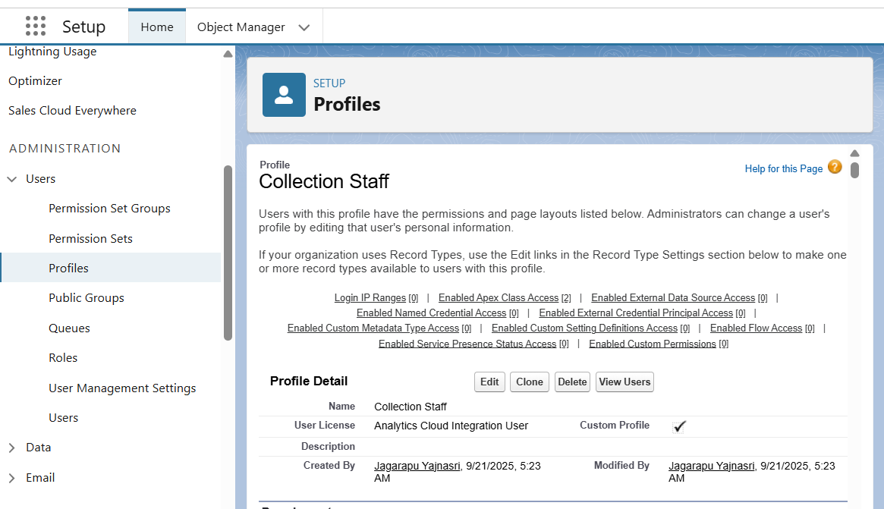

**Step 8: Roles & Hierarchy**

* **Manager** → Top
* **Collection Staff** → Below Manager
* 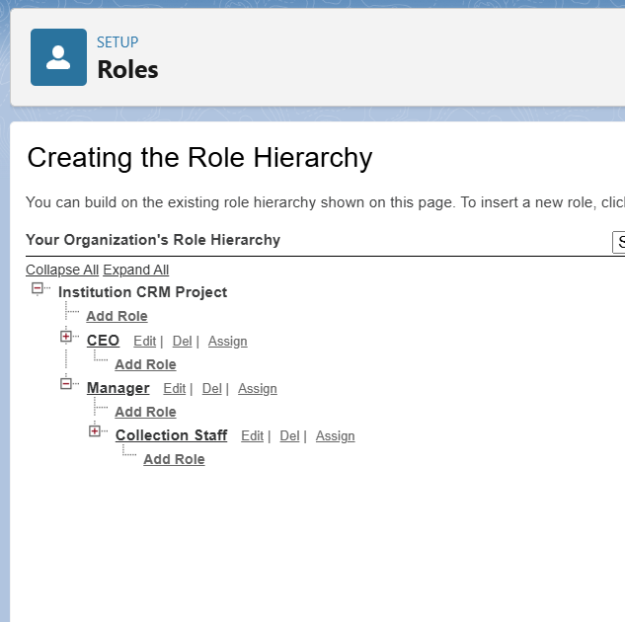

**Step 9: Permission Sets**

* Provide extra access for specific users by creating **Permission Sets**.

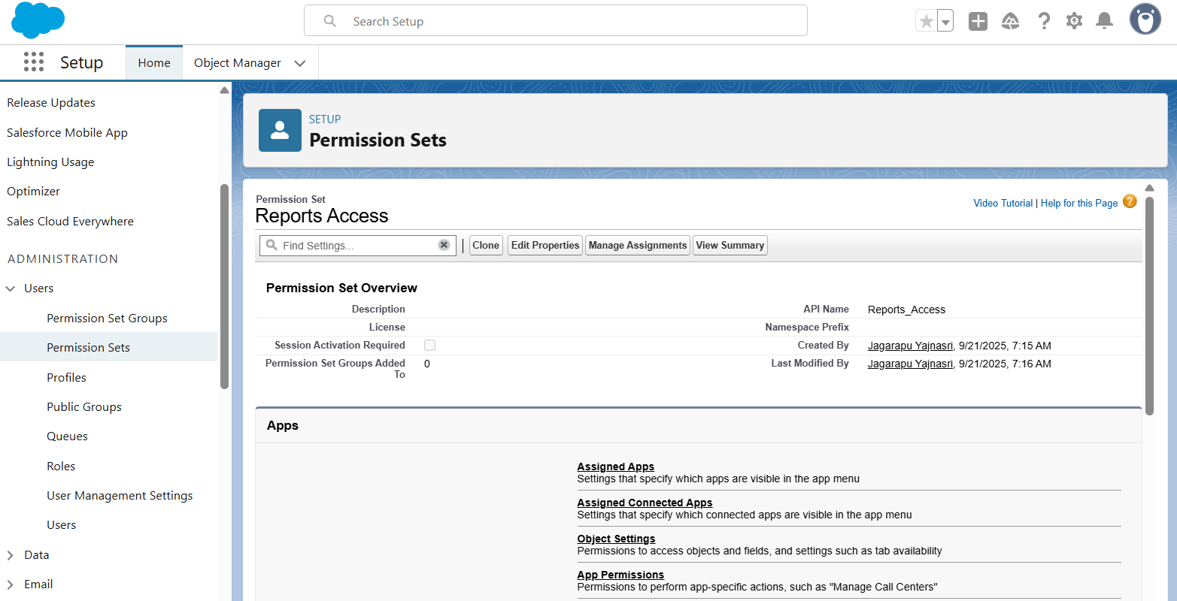

**Step 10: Org-Wide Defaults (OWD)**

* Sensitive/Personal Data → Private
* Reference Data (like courses, programs) → Public Read Only
* Collaboration Data (like service requests) → Public Read/Write

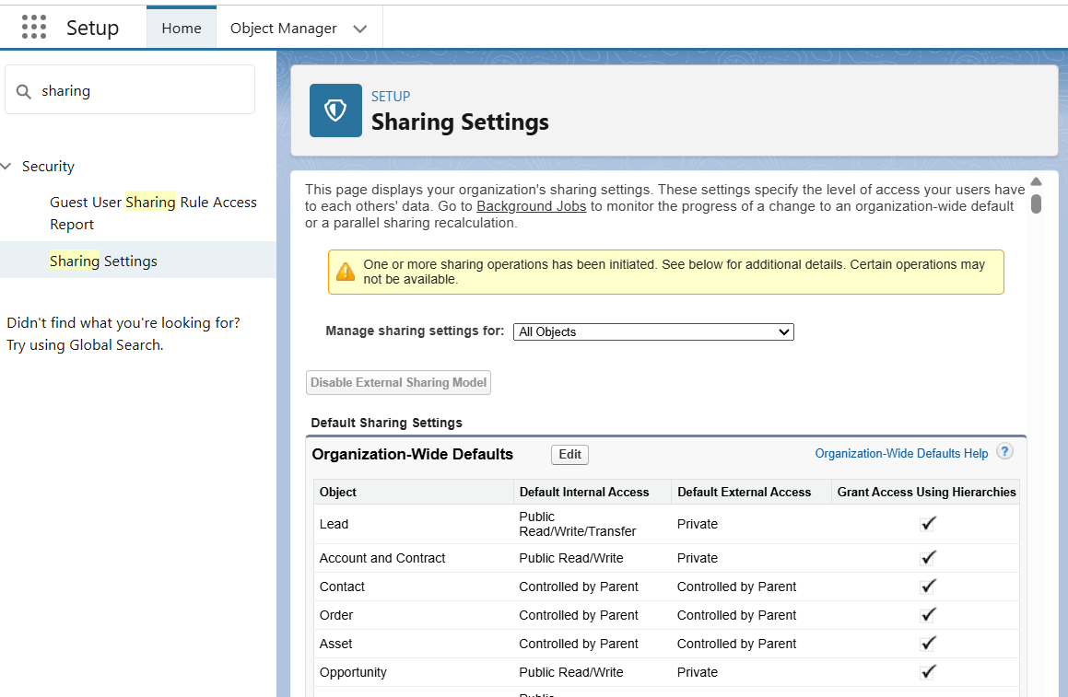

**Step 11: Sharing Rules**

* Create a rule to share **CollectionRecord__c** with **Manager**.

**Step 12: Login Access Policies**

* Restrict login hours for **Collection Staff** → 9 AM – 6 PM.
* 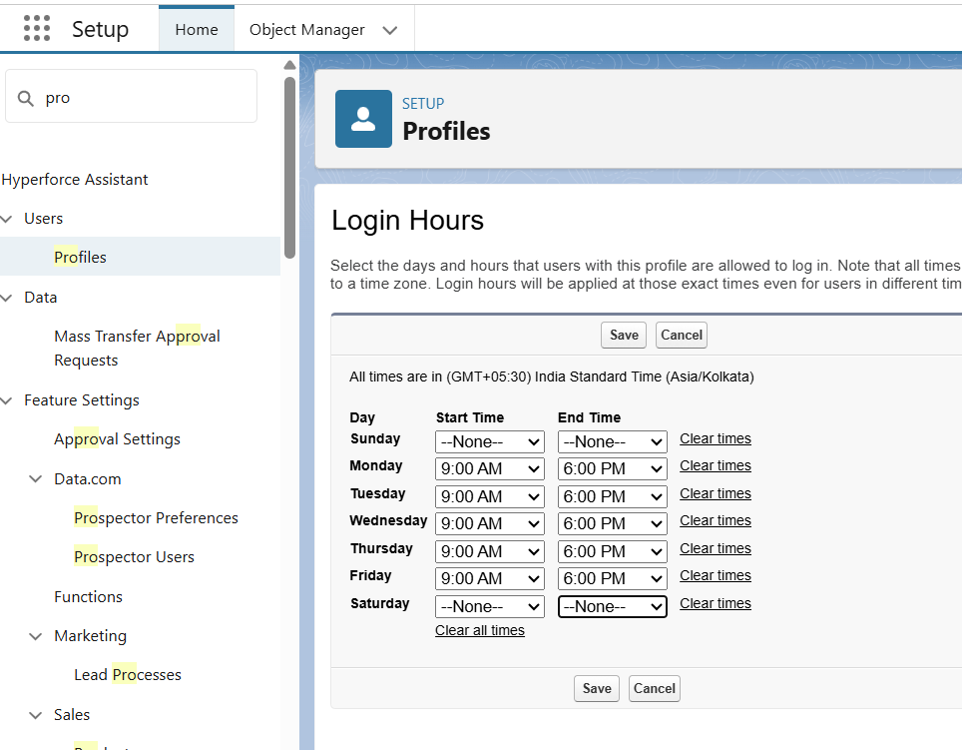

**Step 13: Dev Org & Sandbox**

* Build configurations in **Developer Org**.
* **Sandbox** → mirrors production for testing & practice.

**Step 14: Deployment Basics**

* Move changes **sandbox → production** using:
  + **Change Sets**
  + **VS Code + SFDX**

**Step 15: Expected Outcome (Phase 2 Completion)**

* Salesforce org fully setup.
* Users, Roles, Profiles, Permission Sets, OWD, Business Hours, Holidays configured.